**Rotary Encoder**

**Output:** <https://photos.app.goo.gl/NNG4r2ttzciwoABg9>

**Components:**

* Raspberry Pi
* Breadboard
* Rotary Encoder Module
* Jumper wires
* 40-Pin GPIO Cable
* T-Extension Board

**Connections**:

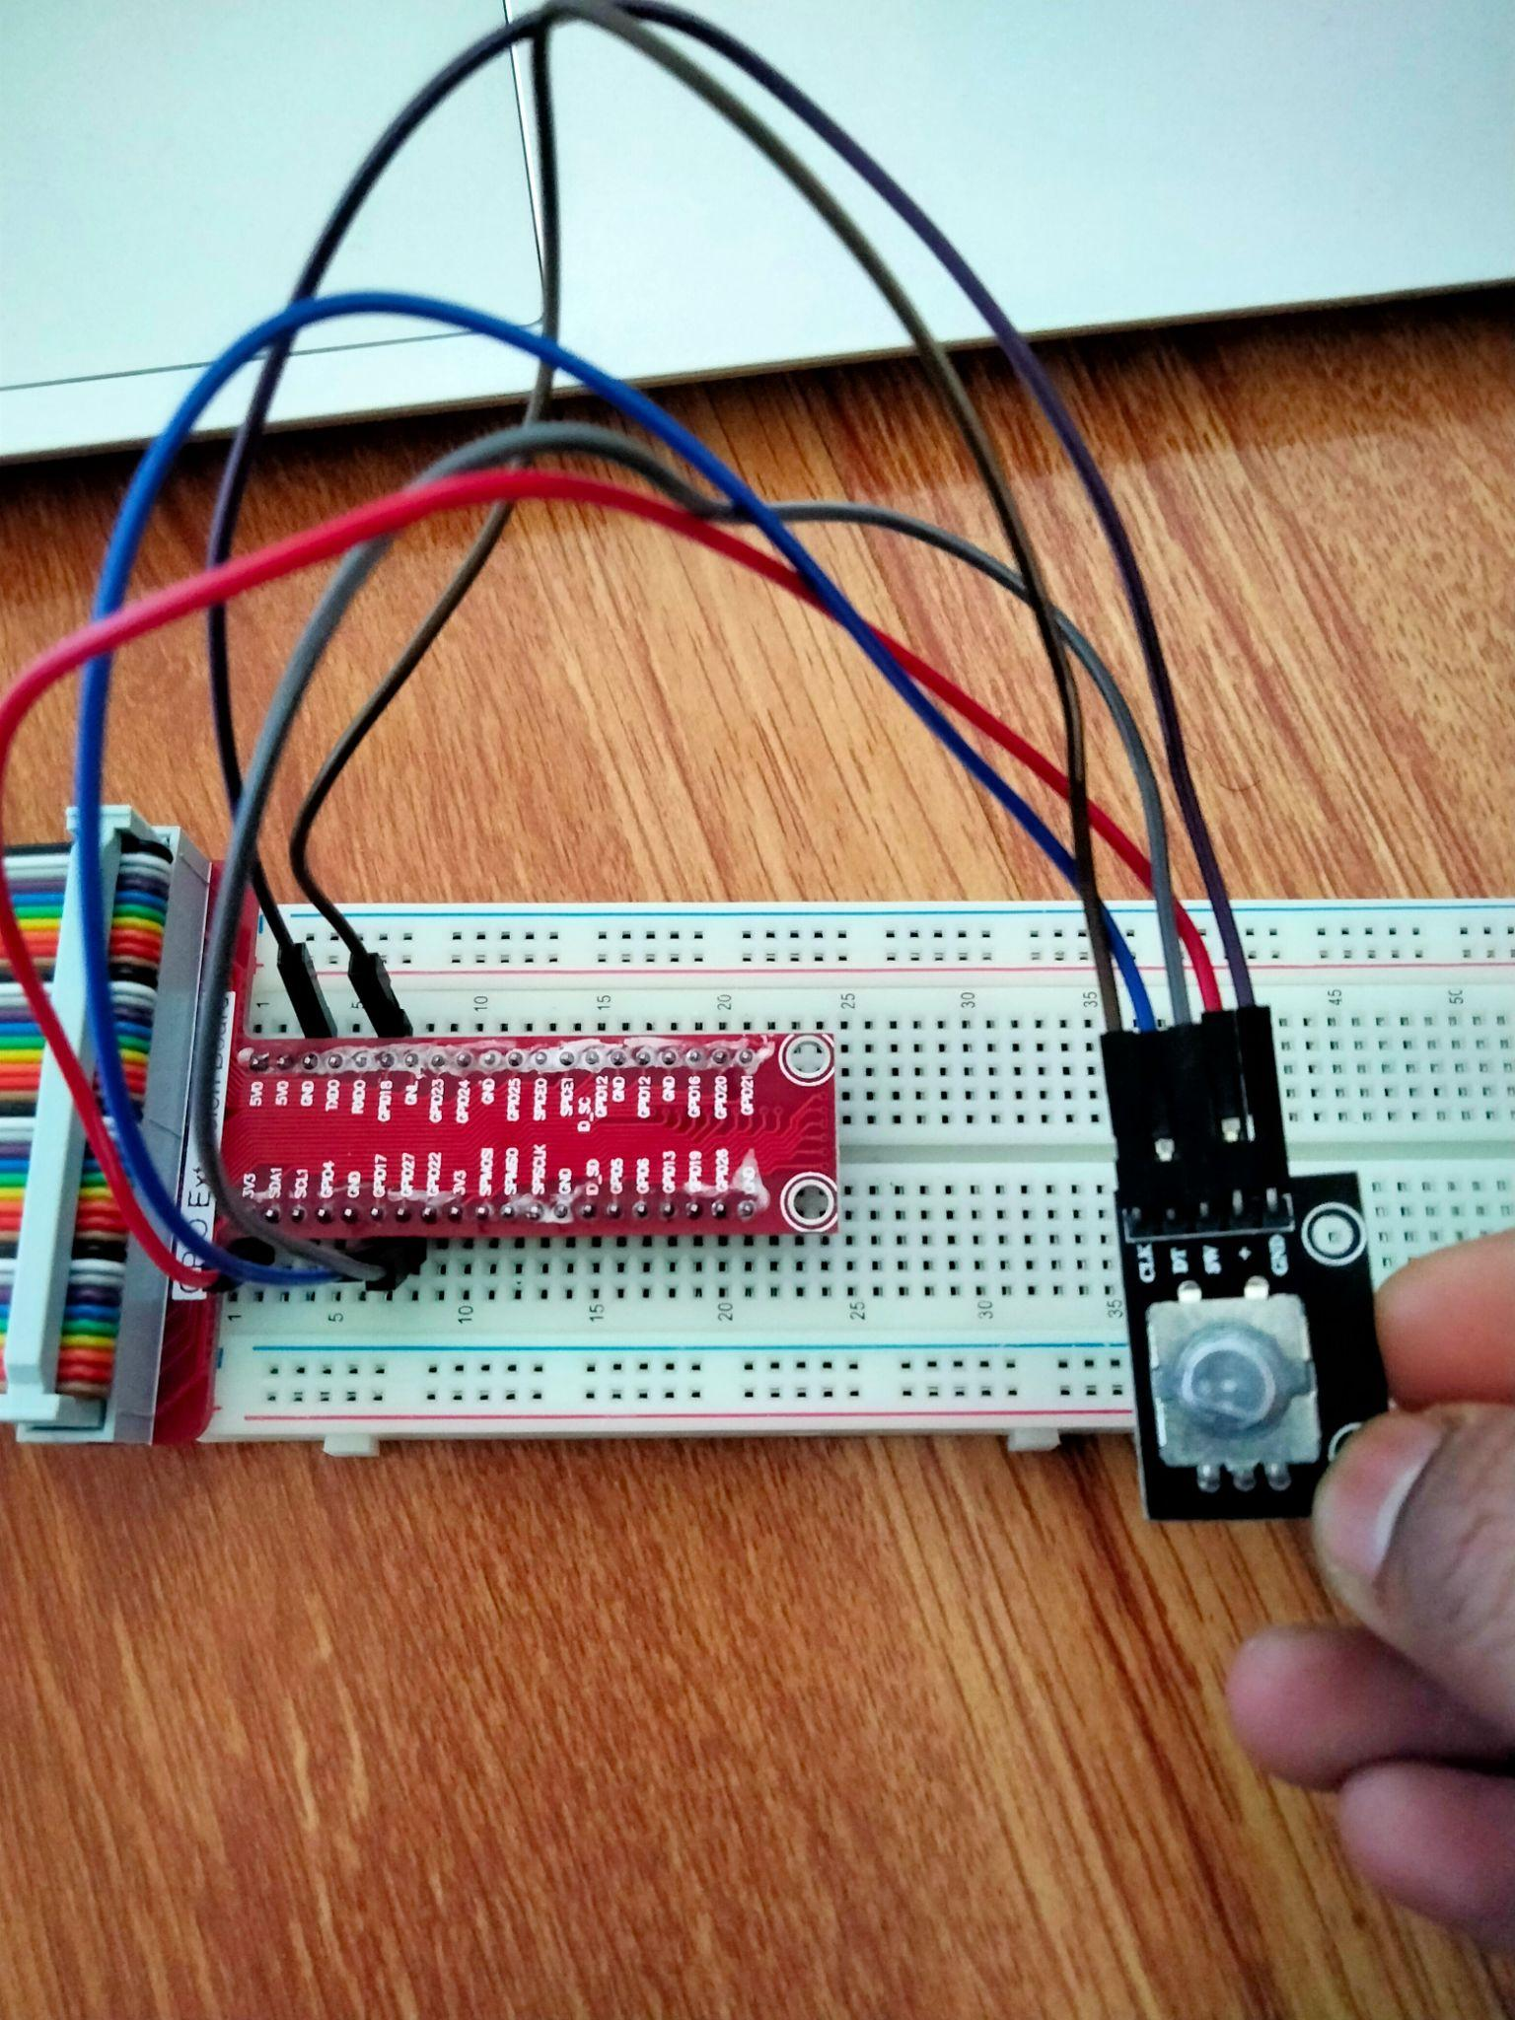

**Working:**

1. Once the wireless connection is established then open thonny Python IDE and open a new file.

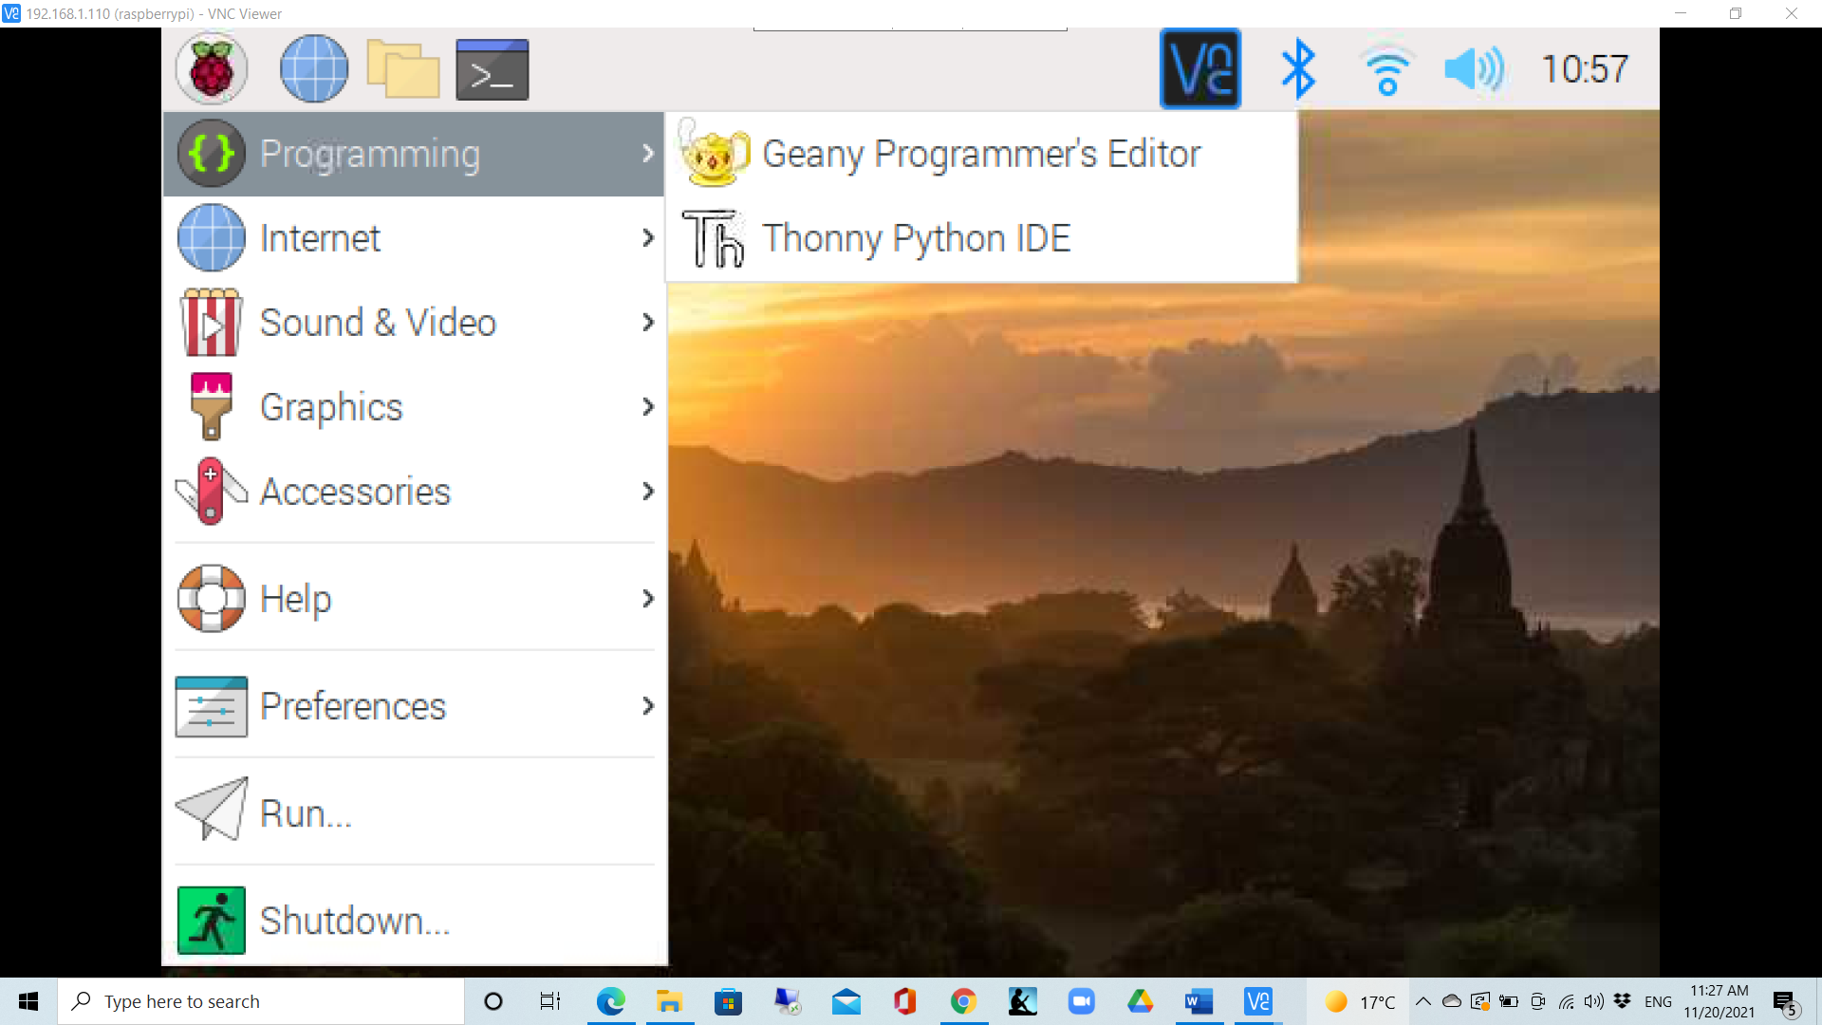

1. Type in the program and save as encoder.py

**# Python Program**

import RPi.GPIO as GPIO

import time

RoAPin = 11 # pin11 -> Connected to CLK

RoBPin = 12 # pin12 -> Connected to DT

RoSPin = 13 # pin13 -> Connected to SW

globalCounter = 0

flag = 0

Last_RoB_Status = 0 # two var. for pin B’s value

Current_RoB_Status = 0

def setup():

GPIO.setmode(GPIO.BOARD) # Numbers GPIOs by physical location

GPIO.setup(RoAPin, GPIO.IN) # input mode

GPIO.setup(RoBPin, GPIO.IN)

GPIO.setup(RoSPin,GPIO.IN, pull_up_down=GPIO.PUD_UP) # Bottom pin

rotaryClear()

def rotaryDeal():

global flag

global Last_RoB_Status

global Current_RoB_Status

global globalCounter

Last_RoB_Status = GPIO.input(RoBPin) # Read in data from DT

while(not GPIO.input(RoAPin)):

Current_RoB_Status = GPIO.input(RoBPin)

flag = 1

if flag == 1:

flag = 0

if (Last_RoB_Status == 0) and (Current_RoB_Status == 1):

globalCounter = globalCounter + 1

print 'globalCounter = %d' % globalCounter

if (Last_RoB_Status == 1) and (Current_RoB_Status == 0):

globalCounter = globalCounter - 1

print 'globalCounter = %d' % globalCounter

def clear(ev=None):

globalCounter = 0

print 'globalCounter = %d' % globalCounter

time.sleep(1)

def rotaryClear():

GPIO.add_event_detect(RoSPin, GPIO.FALLING, callback=clear) # wait for falling

def loop():

global globalCounter

while True:

rotaryDeal()

# print 'globalCounter = %d' % globalCounter

def destroy():

GPIO.cleanup() # Release resource

setup()

try:

loop()

except KeyboardInterrupt: # When 'Ctrl+C' is pressed, the child program destroy() will be executed.

destroy()

1. Run the program in command prompt as:

sudo python encoder.py

1. Now turn the rotary encoder and you can observe the counter increment or decrement according to the direction of the turn.

